SIMATS ENGINEERING (SAVEETHA SCHOOL OF ENGINEERING)
Department of Computer Science and Engineering
CO1 ASSESSMENT TOOL 1 – Case Study Analysis

Course Code: | CSA10 / CSA1063 | Course Title: | Software Engineering
CO Assessed: | CO1 | Assessment: | Assessment Tool 1 – Case Study Analysis
Weightage: | 20% | Total Marks: | 25
CO1 Statement: | Apply advanced methodologies and agile project management techniques to manage software projects effectively
Student Name: | M. Kruthika Reddy | Reg. No.: | 192465037
Date: | 22-07-26 | Duration: | 60 minutes

Code of Conduct
I M. Kruthika Reddy (192465037) (Name / Reg No) certify that this submission is my original work and that I have adhered to the guidelines specified for this assessment. I understand that any violation of academic integrity rules will result in disciplinary action.
Signature of the Student: Malli Chandana

Cloud Security monitoring and vulnerability assessment dashboard

Introduction

A Cloud Security Monitoring and Vulnerability Assessment Dashboard is a centralized platform that helps organizations monitor the security of their cloud infrastructure in real time. As businesses increasingly rely on cloud services to store data and run applications, the risk of cyber threats such as unauthorized access, malware, misconfigurations, and data breaches continues to grow. The dashboard collects security data from cloud resources, system logs, and monitoring tools, providing administrators with a unified view of the organization's overall security posture. This enables faster detection of suspicious activities and supports timely incident response.

In addition to continuous monitoring, the dashboard performs vulnerability assessment by identifying security weaknesses, outdated software, configuration errors, and other potential risks within the cloud environment. It categorizes vulnerabilities based on their severity, helping security teams prioritize remediation efforts and reduce the organization's attack surface. By presenting security metrics, alerts, and reports through an easy-to-understand interface, the dashboard improves decision-making, supports compliance requirements, and enhances the overall protection, reliability, and resilience of cloud-based systems.

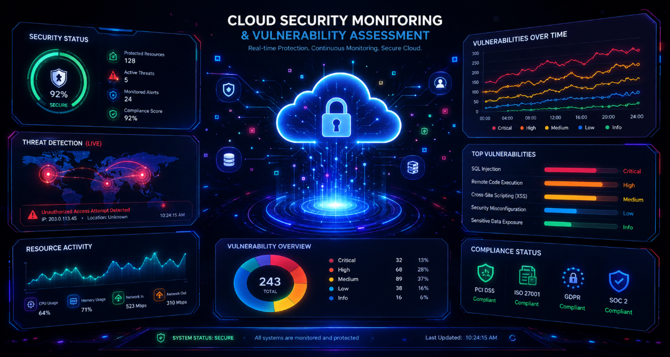

Figure 1:Cloud Security Monitoring and Vulnerability Assessment Dashboard.

Understand the Problem Statement

Explain the Problem Statement

Cloud environments have become the backbone of modern organizations, making them attractive targets for cyberattacks and security breaches. Traditional security monitoring methods often fail to provide continuous visibility into cloud resources, leaving vulnerabilities undetected for long periods. Security teams also face challenges in analyzing large volumes of logs, identifying critical threats, and prioritizing vulnerabilities for remediation. As a result, organizations require an integrated solution that continuously monitors cloud infrastructure, detects security risks in real time, and presents actionable insights through an intuitive dashboard. Such a system helps improve security management and reduces the risk of data breaches.
Key Points:
Continuous monitoring of cloud resources.
Detection of vulnerabilities in real time.
Centralized dashboard for security visibility.
Prioritization of critical security threats.
Faster incident detection and response.

Objectives of the Proposed System

The primary objective of the proposed Cloud Security Monitoring and Vulnerability Assessment Dashboard is to enhance the security of cloud environments through continuous monitoring and automated vulnerability assessment. The system aims to collect security data from multiple cloud services, analyze threats, and present meaningful insights through interactive dashboards. It also helps administrators identify high-risk vulnerabilities, monitor compliance status, and respond to security incidents efficiently. By automating security monitoring and reporting, the system reduces manual effort and improves the overall security posture of cloud infrastructure.
Key Points:
- Monitor cloud infrastructure continuously.
- Identify and classify security vulnerabilities.
- Provide real-time alerts for threats.
- Support compliance and security reporting.
- Improve incident response and decision-making.

Scope of the Proposed System

The proposed system focuses on monitoring cloud-based resources, detecting vulnerabilities, and providing a centralized dashboard for security management. It supports the integration of cloud platforms, security logs, vulnerability scanners, and monitoring tools to provide comprehensive visibility into cloud security. The system generates alerts, visualizes security metrics, and assists administrators in tracking remediation progress. While it improves monitoring and vulnerability management, it does not replace existing cloud security controls such as firewalls or identity management solutions but complements them by providing continuous security insights.
Key Points:
- Covers cloud security monitoring and vulnerability assessment.
- Integrates with cloud platforms and security tools.
- Displays security metrics through dashboards.
- Tracks vulnerabilities and remediation status.
- Enhances existing cloud security mechanisms

Identify Key Stakeholders and Challenges

The key stakeholders of the Cloud Security Monitoring and Vulnerability Assessment Dashboard include cloud administrators, security analysts, IT managers, compliance officers, and organizational management. They are responsible for monitoring cloud resources, managing security incidents, ensuring compliance, and making informed security decisions. The main challenges include detecting threats in real time, identifying critical vulnerabilities, handling large volumes of security data, reducing false alerts, and responding quickly to cyber threats.

Identify Al theStakeholdersInvolved

The proposed Cloud Security Monitoring and Vulnerability Assessment Dashboard involves several stakeholders who contribute to maintaining a secure cloud environment. These include cloud administrators, security analysts, IT managers, compliance officers, and organizational management. Each stakeholder plays a vital role in monitoring cloud resources, managing security incidents, ensuring regulatory compliance, and making strategic security decisions. Their collaboration helps improve the organization's overall security posture and ensures efficient protection of cloud infrastructure and sensitive data.
Key Points
- Cloud Administrators
- Security Analysts
- IT Managers
- Compliance Officers
- Organizational Management

Explain the Roles and Responsibilities of Each Stakeholder

Each stakeholder has specific responsibilities in the proposed system. Cloud administrators manage cloud resources and system configurations, while security analysts monitor threats, investigate alerts, and assess vulnerabilities. IT managers oversee security operations and allocate resources for risk mitigation. Compliance officers ensure adherence to security standards and regulatory requirements, and organizational management reviews security reports to support informed business decisions and improve overall security strategies.
Key Points
- Manage cloud infrastructure and configurations.
- Monitor threats and investigate incidents.
- Perform vulnerability assessments.
- Ensure regulatory compliance.
- Support security planning and decision-making.

Discuss the Major Challenges and Issues Faced by the Stakeholders

Stakeholders face several challenges in securing cloud environments due to the increasing number of cyber threats and the complexity of cloud infrastructure. They must monitor large volumes of security logs, identify critical vulnerabilities, reduce false-positive alerts, and respond quickly to security incidents. Maintaining compliance with security regulations and ensuring continuous monitoring across multiple cloud services are also significant challenges that require effective security management.
Key Points
- Detecting real-time security threats.
- Managing large volumes of security data.
- Reducing false-positive alerts.
- Ensuring compliance with security standards.
- Responding quickly to cyber incidents

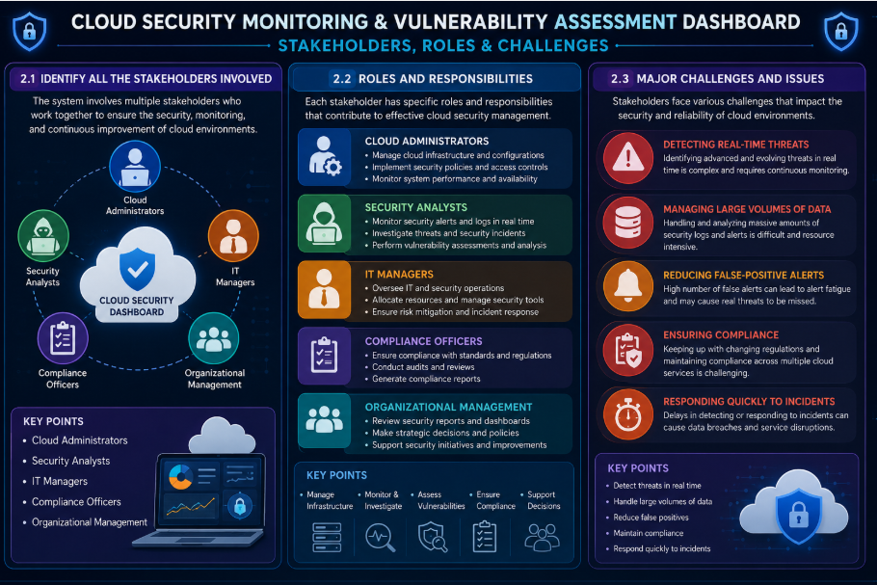

Figure 2: Stakeholders, Roles, and Challenges of the Proposed Cloud Security Monitoring and Vulnerability Assessment Dashboard

Analyze the Current Approach

The current cloud security approach relies on multiple independent tools for monitoring, vulnerability scanning, and log analysis. Security teams manually review alerts and security logs to identify threats, making the process time-consuming and prone to delays. Since security data is distributed across different platforms, it becomes difficult to obtain a centralized view of the organization's security posture. This approach can result in slower incident response, increased false-positive alerts, and challenges in managing large-scale cloud environments. Therefore, there is a need for a unified dashboard that provides continuous monitoring, automated vulnerability assessment, and real-time security insights.

Describe the Existing System or Current Process

The existing cloud security process relies on multiple security tools such as cloud monitoring services, vulnerability scanners, and log management systems that operate independently. Security teams manually collect and analyze logs from different sources to identify threats and vulnerabilities. This fragmented approach makes it difficult to gain a complete view of the cloud environment. The lack of centralized monitoring increases the time required to detect and respond to security incidents. As cloud infrastructures continue to grow, managing security through separate tools becomes more complex and less efficient.

Key Points:

    - Uses multiple independent security tools.
    - Manual analysis of security logs.
    - No centralized security dashboard.
    - Slow threat detection and response.
    - Complex management of cloud resources.

Identify the Strengths of the Existing System

The existing system provides basic security monitoring and vulnerability scanning through reliable cloud security tools. It helps organizations detect known vulnerabilities, monitor user activities, and generate security logs for auditing purposes. Many cloud providers also offer built-in security services that support compliance and access control. These tools provide a strong foundation for cloud security and help reduce common cyber risks. They are widely adopted and supported across different cloud platforms.
Key Points
- Provides basic security monitoring.
- Detects known vulnerabilities.
- Generates security and audit logs.
- Supports compliance requirements.
- Built-in cloud security services.

Identify the Limitations of the Existing System

Despite its advantages, the existing system has several limitations. Security data is often distributed across multiple platforms, making it difficult to correlate events and identify advanced threats. Manual monitoring requires significant time and effort, increasing the possibility of delayed responses. The system may also generate a large number of false-positive alerts, which can overwhelm security teams. Additionally, it lacks a unified dashboard for real-time visualization and vulnerability tracking.
Key Points
- Scattered security information.
- Time-consuming manual monitoring.
- High number of false alerts.
- Delayed incident response.
- No unified monitoring dashboard.

Analyze the Problems or Gaps That Need to Be Addressed

The current approach requires improvements to provide better visibility, automation, and faster threat detection. A centralized dashboard is needed to combine security data from different cloud services into a single interface. Automated vulnerability assessment and real-time alerting can reduce manual effort and improve response time. The system should also prioritize vulnerabilities based on risk severity and provide clear reports for compliance and decision-making. Addressing these gaps will strengthen cloud security and improve operational efficiency.
Key Points
- Need centralized security monitoring.
- Improve real-time threat detection.
- Automate vulnerability assessment.
- Prioritize critical security risks.
- Enhance reporting and compliance support.
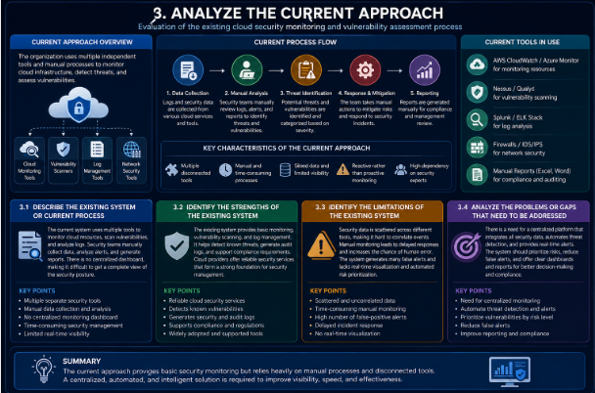

Figure 3: Analysis of the Existing Cloud Security Monitoring Approach.

Propose a Suitable Solution Using Software Engineering Principles

The proposed solution is a Cloud Security Monitoring and Vulnerability Assessment Dashboard that provides continuous monitoring, automated vulnerability detection, and real-time security visualization. The system integrates cloud services, security logs, and vulnerability scanning tools into a centralized dashboard. It helps administrators monitor security events, prioritize vulnerabilities, and respond quickly to cyber threats. By following software engineering principles such as modular design, scalability, maintainability, and reliability, the system ensures efficient security management and supports future enhancements.

Design a Software-Based Solution for the Given Problem

The proposed software solution consists of a centralized dashboard that collects data from cloud resources, vulnerability scanners, and monitoring tools. The system processes security logs, identifies vulnerabilities, and generates real-time alerts for administrators. It also provides interactive charts and reports to help users analyze security trends and compliance status. The modular architecture allows easy integration with different cloud platforms and future security tools, making the system flexible and scalable.
Key Points
- Centralized dashboard architecture.
- Integration with cloud services.
- Automated log collection and analysis.
- Real-time security alerts.
- Scalable and modular design.

Describe the Major Functional Modules of the Proposed System

The proposed system consists of several functional modules that work together to improve cloud security. These include the User Authentication Module, Cloud Resource Monitoring Module, Vulnerability Assessment Module, Security Alert and Notification Module, Dashboard and Reporting Module, and Compliance Monitoring Module. Each module performs a specific task while sharing data with other modules to provide complete security visibility. This modular approach improves system efficiency, maintainability, and performance.
Key Points
- User Authentication Module.
- Cloud Resource Monitoring Module.
- Vulnerability Assessment Module.
- Alert and Notification Module.
- Dashboard and Reporting Module.
- Compliance Monitoring Module.

Identify the Functional and Non-Functional Requirements

The functional requirements include user authentication, cloud resource monitoring, vulnerability scanning, security alert generation, report generation, and compliance tracking. The non-functional requirements include system security, high availability, scalability, reliability, performance, and ease of use. The system should process security events efficiently while protecting sensitive information. These requirements ensure that the dashboard delivers accurate results and provides a secure and user-friendly experience.
Key Points
Functional Requirements
- User authentication.
- Vulnerability scanning.
- Security monitoring.
- Alert generation.
- Report generation.
Non-Functional Requirements
- Security.
- Scalability.
- Reliability.
- High performance.
- User-friendly interface.

Explain How Software Engineering Principles Are Incorporated into the Solution

The proposed system applies software engineering principles to improve quality, maintainability, and reliability. Modular design separates the system into independent components, making development and maintenance easier. Scalability allows the system to support growing cloud environments, while security principles protect sensitive data and user access. Proper testing, documentation, and maintainable coding practices ensure the system remains reliable and can be enhanced with future features without affecting existing functionality.
Key Points
- Modular system architecture.
- Scalable and maintainable design.
- Secure authentication and access control.
- Reliable testing and validation.
- Easy integration and future enhancement.
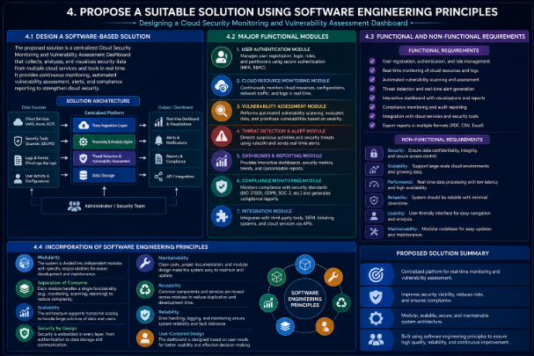

Figure 4: Proposed Software Engineering Solution for Cloud Security Monitoring.

Justify the Chosen Methodology/Framework

The development of the Cloud Security Monitoring and Vulnerability Assessment Dashboard follows the Agile Software Development Methodology because it supports continuous improvement, flexibility, and faster delivery of features. Since cloud security requirements frequently change due to evolving cyber threats, Agile enables developers to adapt quickly by implementing changes in short development cycles. Regular testing and user feedback help improve system quality throughout the project. This methodology ensures that the final system remains secure, reliable, and aligned with user requirements.

Select an Appropriate SDLC Model

The Agile SDLC Model is selected for the proposed system because it divides the project into small, manageable iterations. Each iteration includes planning, development, testing, and deployment, allowing the team to identify issues early and implement improvements continuously. Agile promotes collaboration among developers, testers, and stakeholders throughout the project lifecycle. This approach is well suited for cloud security applications where requirements evolve over time.
Key Points
- Agile SDLC Model.
- Iterative development process.
- Continuous testing.
- Early issue detection.
- Strong team collaboration.

5.2.Justify Why the Selected Methodology is Suitable

Agile is suitable for this project because cloud security systems require frequent updates to address newly discovered vulnerabilities and changing security requirements. The iterative development process allows new features and security improvements to be added without affecting the entire system. Continuous feedback from stakeholders ensures that the dashboard meets organizational needs. Agile also minimizes development risks by identifying and resolving issues early in each iteration.
Key Points
- Handles changing security requirements.
- Supports continuous feature updates.
- Reduces development risks.
- Incorporates stakeholder feedback.
- Improves software quality.

5.3 Explain How It Supports Successful Project Development and Maintenance

The Agile methodology supports successful project development by encouraging continuous communication, regular testing, and incremental software delivery. Each development cycle produces a working version of the system, making it easier to monitor progress and resolve issues quickly. After deployment, Agile simplifies maintenance by allowing updates, bug fixes, and security patches to be implemented efficiently. This approach ensures that the dashboard remains reliable, secure, and capable of adapting to future cloud security challenges.
Key Points
- Continuous communication.
- Incremental software delivery.
- Easy maintenance and updates.
- Regular bug fixing and testing.
- Long-term system reliability.

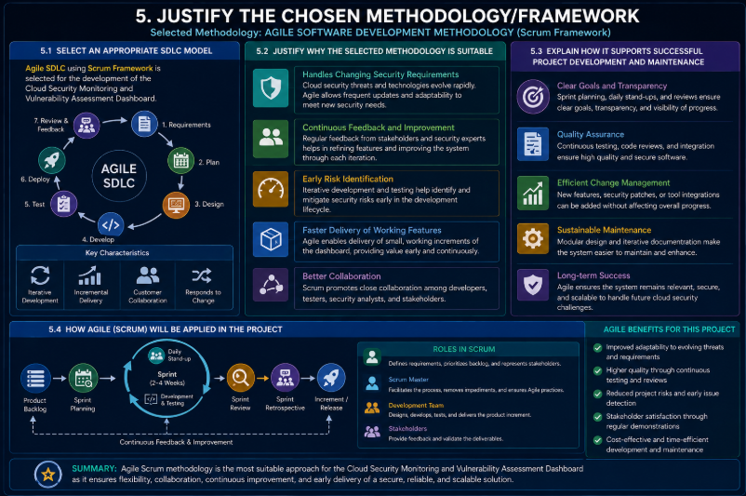

Figure 5.1: Agile SDLC Methodology for the Proposed Cloud Security System.
•

Discuss Expected Outcomes and Limitations

The proposed Cloud Security Monitoring and Vulnerability Assessment Dashboard is expected to improve the overall security of cloud environments by providing continuous monitoring, automated vulnerability assessment, and real-time threat detection. The system enables organizations to identify security risks quickly, respond to incidents efficiently, and maintain compliance with security standards. It also reduces manual effort by automating security analysis and reporting. Although the solution offers significant benefits, it may face challenges such as integration complexity, implementation costs, and evolving cyber threats that require continuous updates.

Describe the Expected Benefits of the Proposed Solution

The proposed solution provides several benefits by enhancing the visibility and security of cloud infrastructure. It enables real-time monitoring of cloud resources, early detection of vulnerabilities, and faster incident response. Automated security analysis reduces manual workload and improves operational efficiency. The dashboard also provides centralized reports and security metrics that support informed decision-making and regulatory compliance, helping organizations strengthen their overall security posture.
Key Points
- Continuous cloud monitoring.
- Early vulnerability detection.
- Faster incident response.
- Reduced manual effort.
- Better security reporting.

Explain How the Solution Addresses the Identified Challenges

The proposed dashboard addresses existing challenges by integrating multiple security tools into a single centralized platform. It automates vulnerability scanning, continuously monitors cloud resources, and generates real-time alerts for security incidents. The system prioritizes vulnerabilities based on their severity, helping administrators focus on critical threats first. It also improves visibility across cloud environments and simplifies compliance monitoring, making security management more effective.
Key Points
- Centralized security monitoring.
- Automated vulnerability scanning.
- Real-time threat alerts.
- Risk-based vulnerability prioritization.
- Improved compliance management.

Discuss Potential Risks, Implementation Challenges, and Limitations

Despite its advantages, the proposed system may face implementation challenges such as integration with different cloud platforms, high deployment costs, and the need for skilled security professionals. The dashboard depends on accurate security data from connected tools, and incorrect configurations may affect detection accuracy. New cyber threats and evolving attack techniques also require continuous updates and maintenance. These limitations should be addressed through proper planning, testing, and regular system improvements.
Key Points
- Integration complexity.
- High implementation cost.
- Dependence on accurate data.
- Need for regular maintenance.
- Evolving cybersecurity threats.

Suggest Possible Future Enhancements

The proposed system can be enhanced by incorporating advanced technologies such as Artificial Intelligence (AI) and Machine Learning (ML) for intelligent threat detection and predictive security analysis. Future versions may include automated incident response, support for multi-cloud environments, and integration with Security Information and Event Management (SIEM) platforms. Enhanced analytics, mobile monitoring applications, and improved compliance automation can further strengthen the system's effectiveness and usability.
Key Points
- AI and Machine Learning integration.
- Automated incident response.
- Multi-cloud environment support.
- SIEM integration.
- Mobile monitoring and advanced analytics.
- 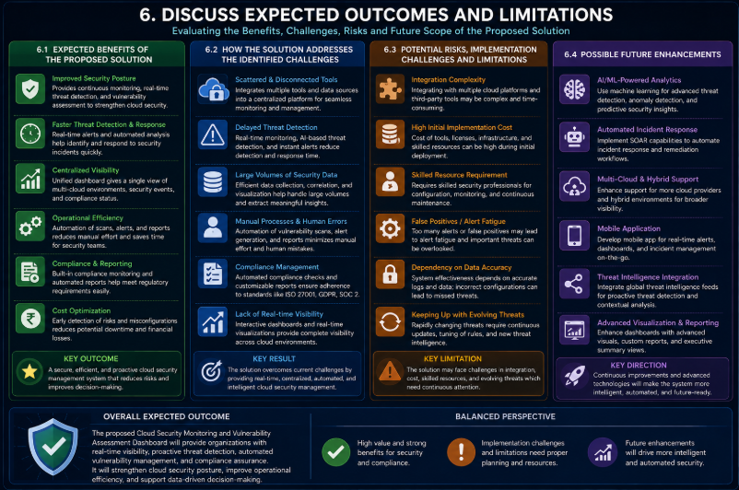

Figure 6: Expected Outcomes, Limitations, and Future Enhancements of the Proposed System.

Conclusion

The Cloud Security Monitoring and Vulnerability Assessment Dashboard provides an effective solution for improving the security of cloud environments through continuous monitoring, automated vulnerability assessment, and real-time threat detection. By integrating security data into a centralized dashboard, the system enables organizations to identify risks quickly, respond to security incidents efficiently, and maintain compliance with industry standards. The proposed solution follows software engineering principles and the Agile SDLC model to ensure scalability, reliability, and ease of maintenance. Overall, the dashboard enhances cloud security, reduces manual effort, supports informed decision-making, and provides a strong foundation for protecting cloud infrastructure against evolving cyber threats.
Rubrics for Calculation

Criteria | Excellent (5 Marks) | Good (3 Marks) | Satisfactory (2 Marks) | Needs Improvement (1 Mark)
Problem Understanding | Clearly explains the problem, objectives, and scope with complete understanding. | Explains the problem with minor omissions. | Basic understanding with limited explanation. | Poor understanding; objectives and scope are unclear or missing.
Stakeholder & Challenge Analysis | Identifies all stakeholders, their roles, and challenges with clear analysis. | Identifies most stakeholders and challenges with adequate analysis. | Identifies only a few stakeholders or challenges. | Stakeholders and system analysis are incomplete or inaccurate.
Current System Analysis | Thoroughly analyzes the existing system, strengths, weaknesses, and identifies all gaps. | Good analysis with most strengths and weaknesses identified. | Limited analysis with partial identification of issues. | Proposed solution is unclear or inappropriate; requirements are largely missing.
Proposed Software Solution & Software Engineering Principles | Proposes an innovative, feasible solution applying appropriate software engineering principles (modularity, scalability, maintainability, security, etc.). | Suitable solution with good application of software engineering principles. | Basic solution with limited application of software engineering principles. | Methodology is inappropriate, poorly justified, or not discussed.
Methodology/ Framework Justification | Selects the most suitable SDLC/model/frame work and provides strong technical justification. | Suitable methodology selected with adequate justification. | Methodology selected but justification is weak. | Outcomes, limitations, or future enhancements are missing; report lacks organization and clarity.

Criteria | Mark
Problem Understanding | /5
Stakeholder & Challenge Analysis | /5
Current System Analysis | /5
Proposed Software Solution & Software Engineering Principles | /5
Methodology/ Framework Justification | /5
TOTAL | /5

